JENNIFER DANIEL

CIT 480

FINAL EXAM - PART 2



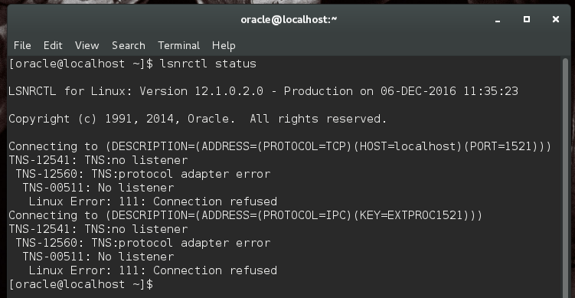



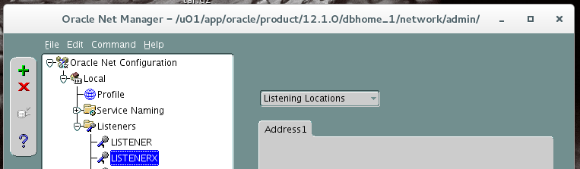



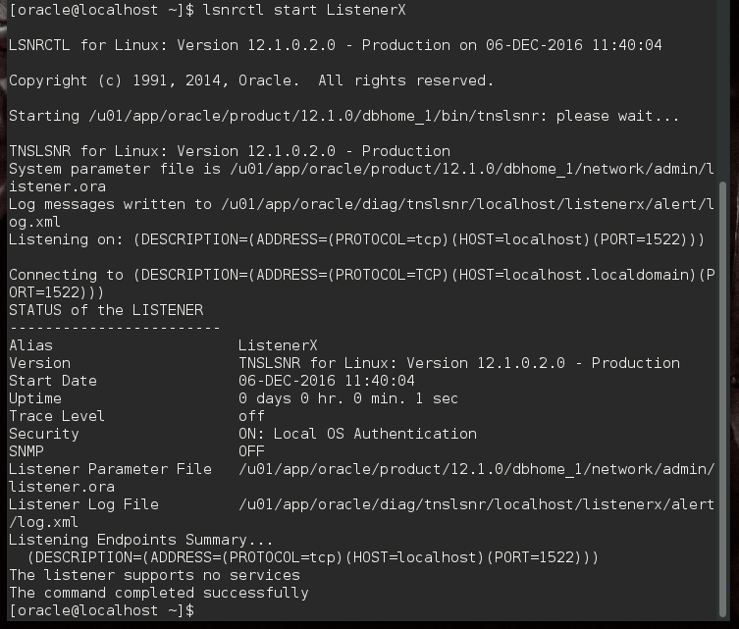

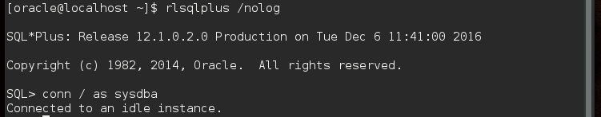

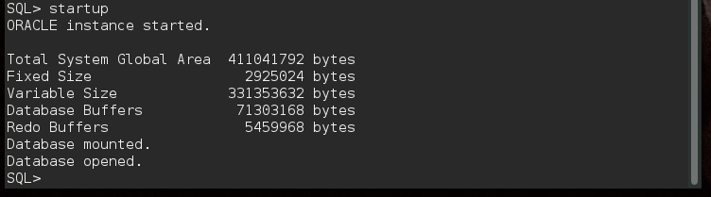

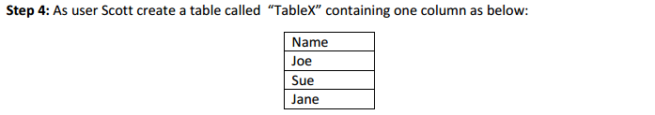

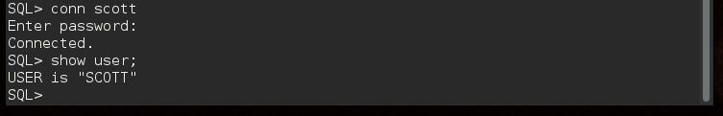



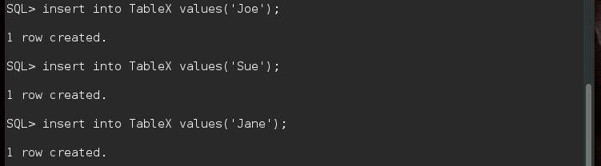



# Scott creates tables in the Users tablespace. Size: 43.3MB. Location:

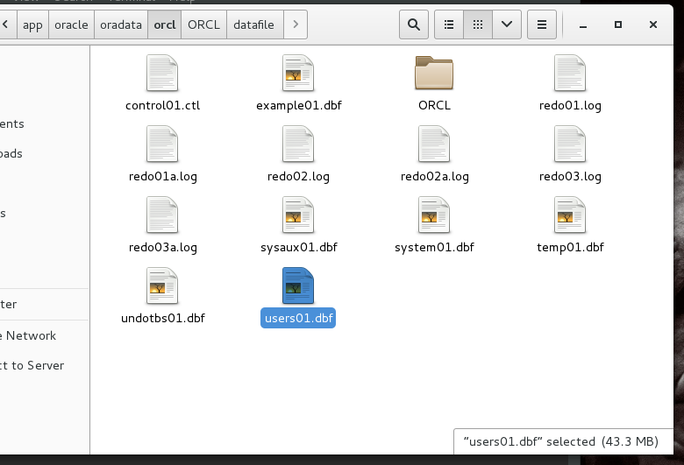





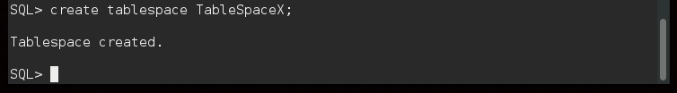



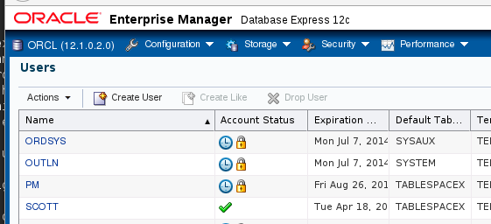

# The TableSpaceX tablespace has been set to default, and those on the default Users tablespace have been moved to TableSpaceX.



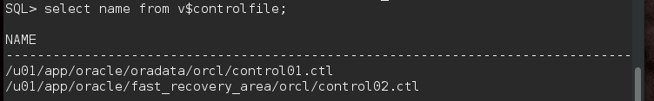





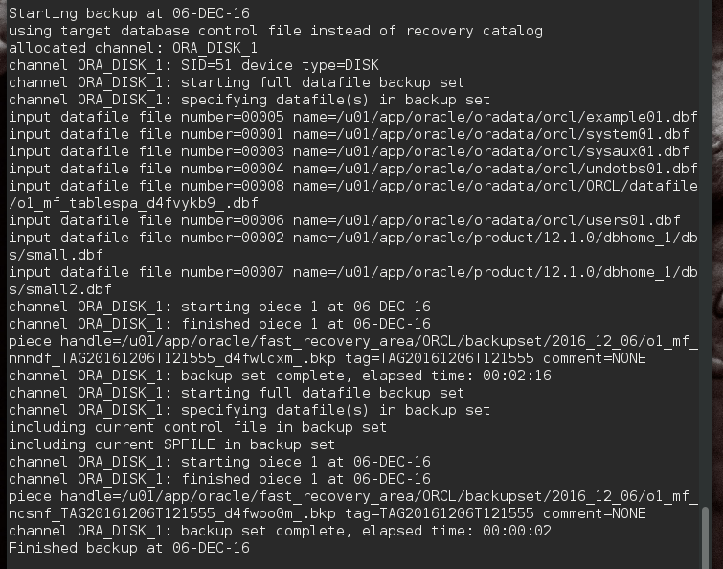



# Oldest:

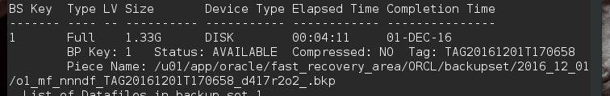



# Backup removed:

